OS CN ASSIGNMENT-08
LAB-07
CH HARSHITHA
HALL TICKET NO: 2503B05135
TASK-01
Q1. A process is a program in execution. In real CPU scheduling, processes do not always arrive at the same time. The First Come First Serve (FCFS) algorithm schedules processes in order of arrival time.
CODE:
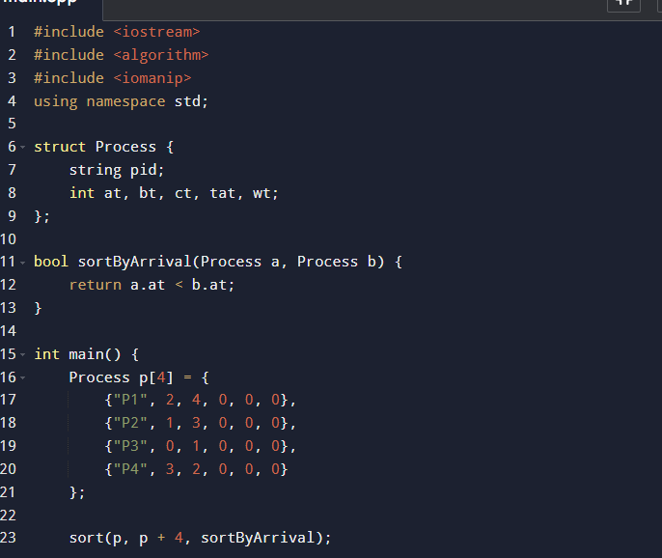
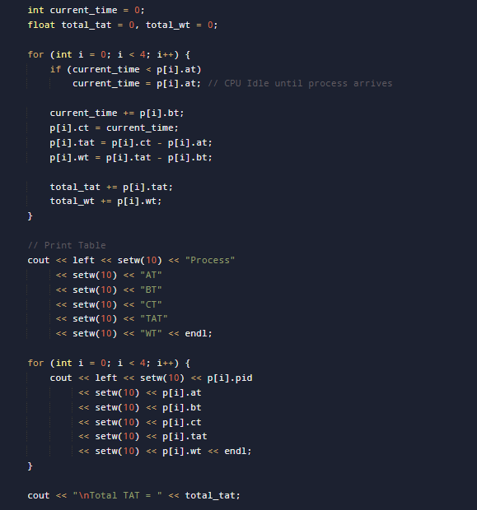
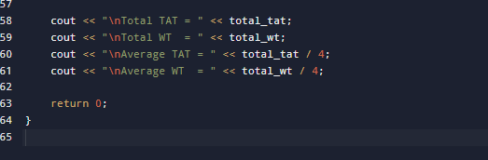
OUTPUT:
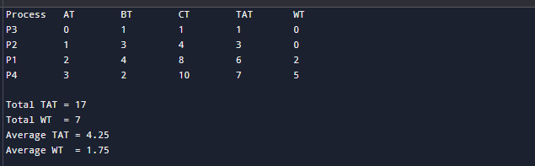

TASK-02:
Q2. Assignment Question: Implement SJF (Shortest Job First) Scheduling Algorithm
A process is a program in execution. CPU scheduling determines which process gets the CPU next.
The Shortest Job First (SJF) algorithm selects the process with the smallest CPU burst time next.
SJF can be:
- Non-preemptive → process runs until completion
- Preemptive (SRTF) → process may be interrupted if a new shorter job arrives
In this assignment, consider Non-preemptive SJF.
CODE:
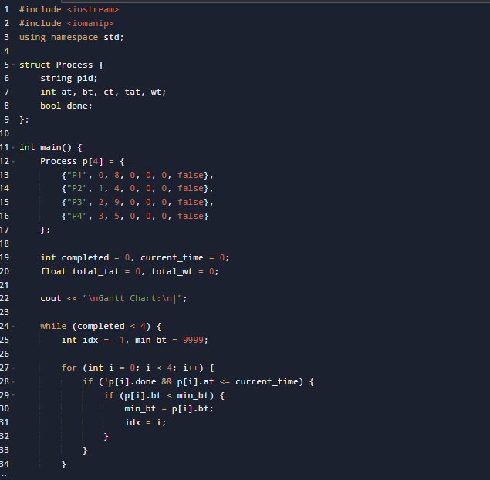
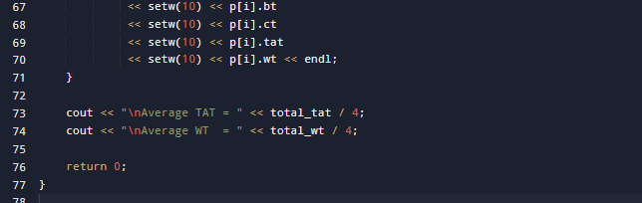
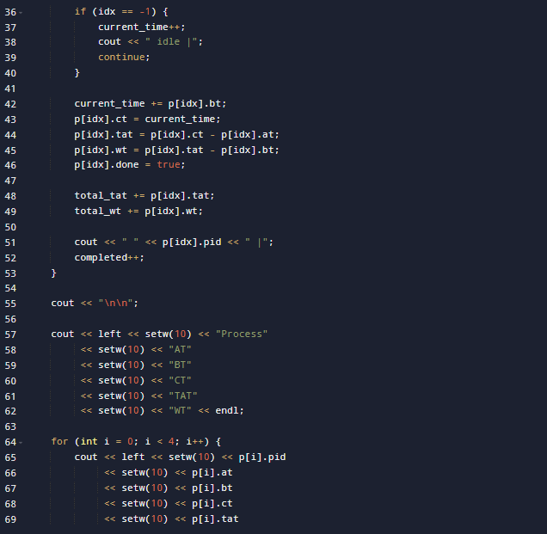
OUTPUT:
